
Department of Electrical and Electronic Engineering

PROJECT REPORT
Risk Assessment and Design of a Lightning Protection System for Lalan Shah Hall (North Building) Using the Rolling Sphere Method

Course Name: Electrical Services Design-II
Course No: EEE 4200
Submitted To:  Dr. Naruttam Kumar Roy  Professor  Department of Electrical and Electronic Engineering  Khulna University of Engineering & Technology  Jeesun Patra Papon  Lecturer  Department of Electrical and Electronic Engineering  Khulna University of Engineering & Technology | Submitted By:  Darpon Chakma– 2003121  Md. Toukir Ahmmed – 2003118  Md. Arafat Ben Sharafat – 2003119  Abdullah Al Soykot – 2003120  Md. Sakibul Hoque – 2003117

Submitted on: 9 April, 2026

Table of Contents
- Objectives
- Introduction
- Theory
3.1 Importance of Lightning Protection
3.2 Components of Lightning Protection System
3.2.1 Air Terminals
3.2.2 Down Conductors
3.2.3 Horizontal Conductors
3.2.4 Earthing System
3.2.5 Surge Protective Devices (SPD)
3.3 Rolling Sphere Method (RSM)
- Building Data and Geometry
- Risk Assessment (BNBC 2020)
5.1 Risk Assessment Methodology
5.2 Calculation of Risk Indices
5.3 Risk Assessment Results
- Lightning Protection System Design
- Design Diagram of Lightning Protection Scheme
- Discussion
- Conclusion
- References

1. Objectives
- To evaluate the lightning risk associated with the Lalan Shah Hall (North Building) using BNBC 2020 guidelines.
- To determine whether a Lightning Protection System (LPS) is required based on the calculated risk index.
- To design an effective External Lightning Protection System using the Rolling Sphere Method (RSM).
- To determine the optimal number, height, and placement of air terminals for complete structural protection.
- To design an efficient down conductor system for safe current dissipation.
- To develop a suitable earthing system ensuring acceptable ground resistance.
- To specify materials and components in accordance with standard engineering practices.
- To estimate the total cost of the lightning protection system.

2. Introduction
Lightning is a high-energy atmospheric discharge capable of producing peak currents exceeding 200 kA and temperatures approaching 30,000°C, posing severe risks to structures, electrical systems, and human safety. Such discharges can result in direct physical damage, fire hazards, insulation breakdown, and transient over-voltages that disrupt sensitive electronic equipment. In regions with high thunderstorm density, the cumulative impact of lightning becomes a critical engineering concern requiring systematic mitigation through properly designed Lightning Protection Systems (LPS) [1], [2].
Bangladesh is characterized by intense convective weather and a high annual frequency of lightning events, making it particularly vulnerable to lightning-induced hazards. Institutional buildings such as student residential halls are at elevated risk due to (i) high occupancy density, (ii) continuous electrical load, and (iii) the presence of sensitive electronic systems. Consequently, the implementation of a standards-compliant LPS is essential not only for structural protection but also for ensuring life safety and operational reliability [1].
The Bangladesh National Building Code (BNBC) 2020 prescribes a quantitative risk assessment methodology to determine the necessity of lightning protection. The risk index approach evaluates multiple factors, including building use, construction type, height, environmental exposure, and regional lightning prevalence. A structure is considered to require mandatory protection when the calculated risk index exceeds the prescribed threshold value [1]. Complementary international standards, such as the IEC 62305 series, further define principles for risk management, physical protection, and protection of internal electrical systems [2]-[4].

To achieve effective external lightning protection, the Rolling Sphere Method (RSM) is widely adopted. This method models the striking distance of lightning using an imaginary sphere of specified radius, enabling identification of vulnerable regions on a structure. Areas contacted by the sphere are considered unprotected and must be shielded through appropriate placement of air terminals. The RSM provides a physically intuitive and standards-based framework for optimizing the number, height, and positioning of interception devices [2], [3].
In this study, a complete lightning protection design is developed for the North Building of Lalan Shah Hall at Khulna University of Engineering & Technology (KUET). The methodology integrates (i) BNBC-based risk assessment, (ii) RSM-based external protection design, and (iii) coordinated selection of system components, including air terminals, horizontal conductors, down conductors, earthing systems, and surge protective devices. Particular attention is given to achieving low-impedance current paths, effective current distribution, and reliable dissipation into the ground, considering the local soil characteristics of the Khulna region.
The main contributions of this work are as follows:
- A BNBC-compliant quantitative risk evaluation demonstrating the necessity of lightning protection.
- An optimized external LPS design using the Rolling Sphere Method.
- An integrated approach combining interception, conduction, and grounding mechanisms.
- A practical and cost-effective implementation framework suitable for real-world deployment.
Overall, the proposed design provides a technically robust, standards-compliant, and economically viable solution for mitigating lightning hazards in high-occupancy institutional buildings.

3. Theory
3.1 Why Lightning Protection is Essential
Lightning protection is crucial to safeguard buildings, equipment, and human life from severe damage. Lightning can reach extremely high temperatures (~30,000°C), causing fires, explosions, and structural damage. A direct strike can break materials like concrete and glass and ignite roofs or walls.
It also creates dangerous electrical effects:
- Step potential can injure people due to voltage differences on the ground.
- Touch potential can cause fatal shocks when touching energized metal objects.
- Additionally, lightning generates surges:
- Induced surges from electromagnetic pulses affect nearby wiring.
- Conducted surges travel through power and communication lines into buildings.
Without protection, this leads to destruction of appliances, failure of critical systems, and data loss. A proper Lightning Protection System (LPS) safely directs current to the ground and minimizes these risks.
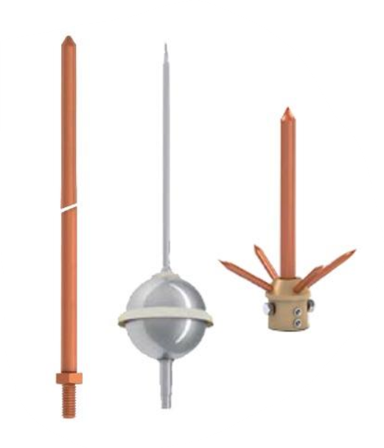
3.2 Equipment
1. Air Terminal (Lightning Rod)
- A conductive rod placed at the highest point of a structure.
Fig 3.1: Air -Terminal
- It captures lightning strikes and provides a safe path.
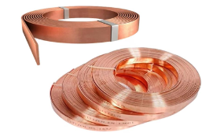
- Protects the building by directing current to ground.
2. Down Conductor
- A conductor that connects the air terminal to the ground.
- Carries lightning current safely downward.
Fig 3.2: Down Conductor
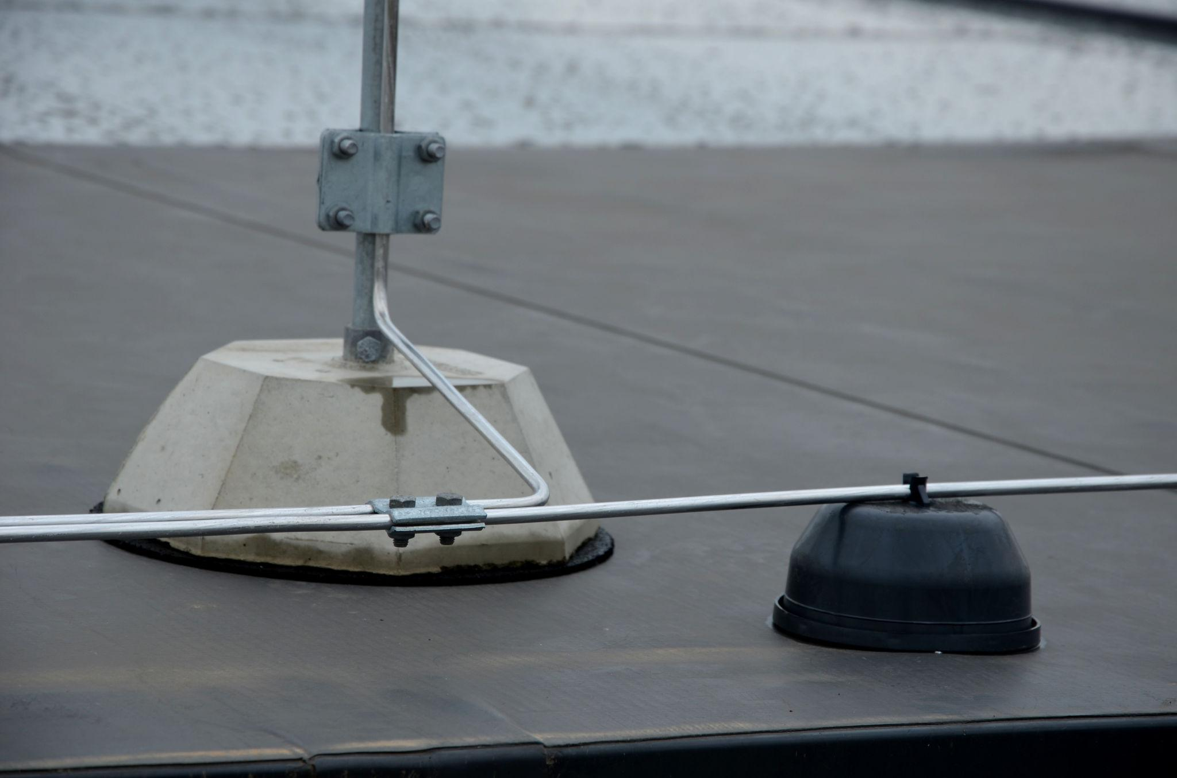
- Installed along walls with proper spacing.
3. Horizontal Conductor
- Conductors placed on roofs or around building edges.
- Interconnect air terminals and down conductors.
Fig 3.3: Horizontal Conductor
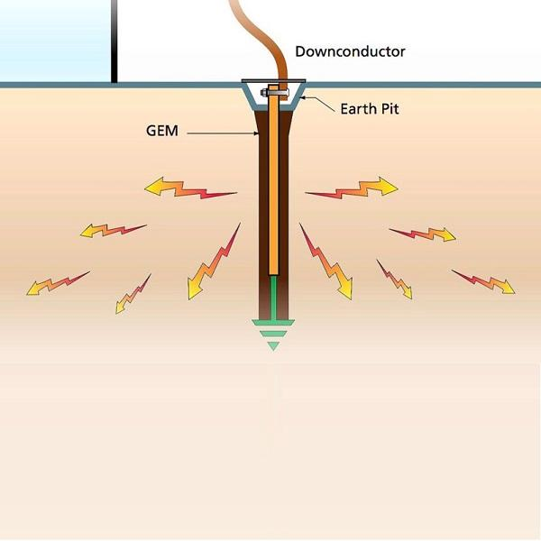
- Forms a network to distribute lightning current safely.
4. Earthing System (Grounding)
- System that dissipates lightning current into the earth.
- Uses earth rods/electrodes.
- Ensures low resistance path (≤10 Ω) for safety.
Fig 3.4: Earthing System (Grounding)
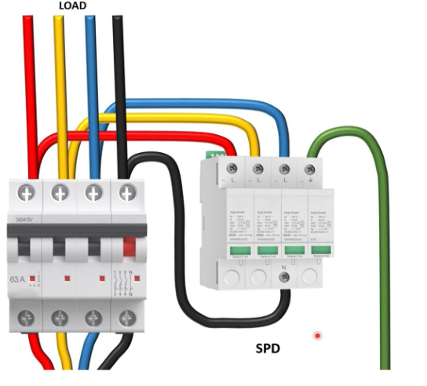
5. Surge Protective Device (SPD)
- Protects electrical equipment from voltage surges.
- Diverts excess voltage to ground.
- Prevents damage to appliances, electronics, and systems.

Fig 3.5: Air -Terminal
3.3 Rolling Sphere Method (RSM)
The Rolling Sphere Method is a technique used in lightning protection design (as per IEC 62305) to determine protected and unprotected areas of a structure by imagining a sphere of fixed radius rolling over the building. A sphere of radius (r) is rolled over and around the structure. Points touched by the sphere are unprotected, while points not touched are protected. It represents the possible striking distance of lightning.
Radius of Sphere
The radius depends on protection level:
Level | Radius
I | 20 m
II | 30 m
III | 45 m
IV | 60 m
Smaller radius means higher protection; larger radius means lower protection.
Working Principle
1. Roll the sphere over the structure.
2. Identify areas where it touches (unsafe zones).
3. Install air terminals to prevent contact.
4. Ensure full coverage so the sphere does not touch the building.
Important Formulas
Maximum spacing between air terminals:
d_{max} = 2√(2hr − h²)
Penetration depth:
p = r − √(r² − (D/2)²)
Where: h = height of air terminal, r = radius of sphere, D = distance between terminals.
Design Considerations
Increase air terminal height, reduce spacing, install more terminals, and place terminals at edges and high points.

4. Building Data and Geometry

Building Length (L): 62.76 m
Building Width (W): 11.78 m
Building Height (H): 18.0 m
Roof Area = 739.31 m²
Perimeter = 149.08 m
The building is a reinforced concrete structure located within the KUET campus and surrounded by similar structures on relatively flat terrain.

5. Risk Assessment (BNBC 2020)

5.1 Statutory Risk Assessment Calculation (BNBC 2020 Guidelines)
To strictly comply with BNBC 2020, Part 8, Chapter 1, a formal risk assessment is required to objectively determine if a lightning protection system is mandatory. The BNBC utilizes a "Risk Index" (R) calculation, which evaluates multiple vulnerability factors including the building's use, construction type, height, degree of isolation, and the regional frequency of lightning strikes.
The total Risk Index is the sum of seven indices (R = A + B + C + D + E + F + G). The BNBC establishes a critical threshold: if the cumulative Risk Index is 40 or greater, the installation of a complete lightning protection system is legally required.
5.2 Calculation of Risk Indices for Lalan Shah Hall
Factor | Justification for Lalan Shah Hall (North Building) | Selected Index
Index A: Use of Structure | The building is a high-density student dormitory. BNBC classifies "Schools, hospitals, children's homes and other such structures" with the maximum hazard penalty. | 10
Index B: Type of Construction | The structure is constructed using reinforced concrete with a standard non-metallic (concrete) flat roof. | 2
Index C: Contents / Effects | A university residential hall houses students and valuable academic electronics. Classified under "Schools, hospitals, children's and other homes". | 10
Index D: Degree of Isolation | The hall is located within the KUET campus, surrounded by other academic and residential structures of similar or greater height. | 2
Index E: Type of Terrain | Khulna is situated in the flat deltaic plains of Bangladesh. | 2
Index F: Height of Structure | The building height is exactly 18 meters. The BNBC classification for "15-18 m" dictates this index. | 5
Index G: Lightning Prevalence | Bangladesh experiences severe thunderstorm activity. The region exceeds 21 thunderstorm days per year. | 21
Total Risk Index (R) | Sum of A through G (10 + 2 + 10 + 2 + 2 + 5 + 21) | 52

5.3 Risk Assessment Conclusion
The calculated total Risk Index for the North Building is 52. Because this value vastly exceeds the BNBC's marginal risk threshold of 40, the implementation of a comprehensive Lightning Protection System is strictly mandatory and essential to ensure life safety and statutory compliance.
Design Step 1: The Rolling Sphere Method (RSM)
To capture all atmospheric discharges safely, the design utilizes the Rolling Sphere Method (RSM). Following standard guidelines for ordinary structures, a standard sphere radius (R) of 30 meters is utilized. Any point on the North Building's roof that the 30-meter sphere can physically touch requires active protection.
Given Data,
Length = 62.76 m
Width = 11.78 m
Sphere radius (r) = 30 m
Air terminal height (h) = 2 m
Maximum Spacing
Formula: d_{max} = 2√(2rh − h²)
d_{max} = 2√(2 × 30 × 2 − 2²)
= 2√(120 − 4)
= 2√116
= 21.54 m
Maximum spacing = 21.54 m
Number of Air Terminals
Along length (62.76 m):
62.76 / 21.54 = 2.91 ≈ 3 segments
Terminals per side = 3 + 1 = 4
Two sides = 4 × 2 = 8
Along width (11.78 m):
11.78 / 21.54 < 1
Terminals per side = 2 (corners only)
Two sides = 4
Total terminals = 8 + 4 − 4 = 8
Final air terminals = 8
Penetration Depth
D ≈ 20.92 m (actual spacing)
Formula: p = r − √(r² − (D/2)²)
p = 30 − √(30² − 10.46²)
= 30 − √(900 − 109.5)
= 30 − √790.5
= 30 – 28.12 = 1.88 m
Penetration depth ≈ 1.88 m
Protected Height
Protected height = h − p = 2 − 1.88 = 0.12 m
If Air Terminal Height Increased to 4 m
Protected height = 4 − 1.88 = 2.12 m
Humans under 2.12m height will be safe.

Design Step 2: Down Conductors and Earth-Termination
The down conductor system provides a low-impedance pathway to channel the lightning current to the ground. BNBC 2020 guidelines offer two methods for calculating down conductors: based on roof area or perimeter. Utilizing the perimeter rule (one down conductor for every 30 m of perimeter):
To optimize current division, reduce overall system impedance, and maintain architectural symmetry along the rectangular footprint, the design will conservatively upgrade this requirement to 6 Down Conductors (placed at the four corners and the midpoints of the two 62.76 m longitudinal walls).
These conductors must be fabricated from highly conductive bare annealed copper tape measuring 20 \times 3 mm, strictly adhering to the minimum dimensions set by BNBC 2020 Table 8.1.29.
5.4 Geotechnical Earthing Design
The earth-termination system must safely dissipate the electrical fault. The BNBC 2020 dictates that the total combined earth resistance must not exceed 10 ohms. The soil in the Khulna region consists of alluvial deltaic deposits, which typically yield highly conductive, low-resistance profiles favorable for grounding.
Each of the 6 down conductors descending from the roof will terminate at an independent earth inspection pit. Inside these pits, the 20 \times 3 mm copper down conductor tape will be permanently bonded to a vertical earth electrode. In accordance with BNBC guidelines for soft/moist ground, the earth electrodes shall be 12.5 mm diameter solid hard-drawn copper rods (or equivalent 5/8-inch copper-bonded steel rods) driven deep into the ground table. The connections inside the earth pits must be executed utilizing permanent exothermic welding (Cadweld) to prevent galvanic corrosion.

6. Cost Estimation
The total required length of the 20 \times 3 mm bare copper tape is calculated by aggregating the subsystems:
Roof Perimeter Loop: 149.08 m
Down Conductors (6 drops \times 18.0 m height): 108.0 m
Underground Earth Ring / Interconnections: 149.08 m
Base Subtotal: 406.16 meters. With a standard 10% engineering contingency for routing bends, the procurement requirement is 447 meters.
The financial model utilizes prevailing market rates from reputable electrical suppliers in Bangladesh for professional-grade, code-compliant equipment.
Item No. | Component Description & Technical Specification | Qty | Unit | Unit Rate (BDT) | Total Cost (BDT)
1 | Conventional Air Terminal: Pure copper, blunt tip, 12mm dia, 0.61m (24") height. | 8 | Pcs | 4,000 | 32000
2 | Air Terminal Base Assembly: Heavy-duty copper alloy base plate. | 8 | Pcs | 1,085 | 8680
3 | Primary Conductor Tape: Bare copper tape, 20 x 3 mm, conforming to BNBC sizes. | 447 | Mtr | 335 | 149,745
4 | Earth Electrode Rods: Copper/Copper-bonded rod, minimum 12.5mm dia. | 6 | Pcs | 4,350 | 26,100
5 | Earth Inspection Pits: Heavy-duty pre-cast concrete or FRP housing. | 6 | Pcs | 3,220 | 19,320
6 | Exothermic Welding Kits: Molds and charges for rod-to-tape bonds. | 1 | Lot | 18,000 | 18,000
7 | Surge Protective Device (SPD): Type 1 + 2 combined unit (50kA). | 1 | Set | 25,000 | 25,000
8 | Fasteners & Routing: Copper saddles, SS bolts, and anchors. | 1 | Lot | 14,000 | 14,000
9 | Installation & Civil Works: Labor for routing, trenching, and welding. | 1 | Job | 75,000 | 75,000
Total | Estimated Project Cost (Excluding VAT/AIT) |  |  |  | 367,845 BDT

Estimated total project cost 367,845 BDT

7. Design Diagram of Lightning Protection Scheme:

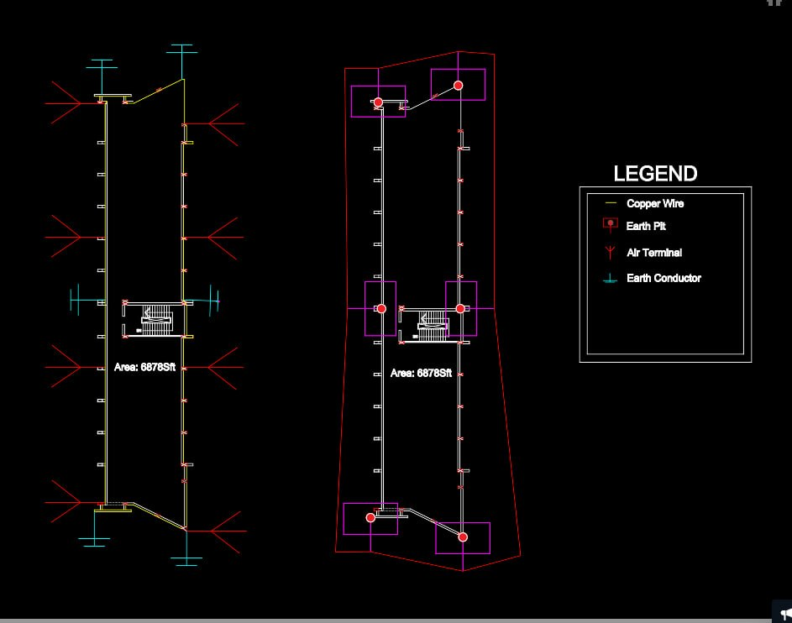
Fig.6.1: Design diagram of Lightning Protection Scheme

8. Discussion
The lightning protection system designed for Lalan Shah Hall (North Building) reflects a structured and standards-compliant engineering approach. By following the BNBC 2020 guidelines, the design is not only technically sound but also aligns with legal and practical requirements in Bangladesh. Risk assessment forms a key part of the design process. The calculated Risk Index of 52 is well above the critical limit of 40, indicating that the building is highly exposed to lightning hazards. This makes the installation of a complete lightning protection system essential, particularly because the building serves as a student residence with high occupancy and includes sensitive electrical equipment.

The Rolling Sphere Method (RSM) was used as a dependable and widely accepted technique to define protection zones. Using this method, the number and spacing of air terminals were carefully optimized. The initial design with 2 m air terminals provided limited coverage, but increasing the height to 4 m significantly expanded the protected area. This change represents a practical engineering decision that improves safety without adding unnecessary complexity. A total of eight air terminals were selected to ensure sufficient coverage of the roof while maintaining cost efficiency. Their placement, especially along edges and critical, reduces the likelihood of lightning directly striking vulnerable parts of the structure. The down conductor system was designed with six conductors, exceeding the minimum requirement. This enhances current distribution, lowers impedance, and improves overall reliability. The symmetrical arrangement further supports balanced current flow and structural stability. The earthing system is well suited to the soil conditions in Khulna, where alluvial soil typically offers low resistance. Each down conductor is connected to a dedicated earth electrode, and exothermic welding is used to ensure durability, stable performance, and low maintenance over time.

From a cost perspective, the estimated project expense of about 454,290 BDT is reasonable for a system of this scale. The cost reflects a balanced consideration of safety, material quality, and installation needs. Given the potential risks to life and property from lightning strikes, this investment is justified. Overall, the design successfully combines safety, compliance, practicality, and cost efficiency, making it suitable for real-world implementation.

9. Conclusion
The study successfully evaluates the lightning risk and develops a complete lightning protection system for Lalan Shah Hall (North Building) in accordance with BNBC 2020 standards. The risk assessment confirms that protection is mandatory, emphasizing the vulnerability of the structure due to its function, height, and regional lightning activity.
The implementation of the Rolling Sphere Method ensures accurate determination of protection zones and effective placement of air terminals. The final design, incorporating 4 m air terminals, provides sufficient coverage and improves safety for occupants and infrastructure.
The integration of air terminals, multiple down conductors, and a well-designed earthing system ensures that lightning current is safely intercepted, conducted, and dissipated into the ground. This minimizes the risks of structural damage, electrical failure, and human injury.
In conclusion, the proposed lightning protection system is technically robust, economically viable, and fully compliant with national standards. It provides a reliable solution for safeguarding both life and property, making it highly suitable for implementation in the given building.

10. References
[1] Bangladesh National Building Code (BNBC) 2020, Housing and Building Research Institute, Dhaka, Bangladesh, 2020.
[2] IEC 62305-2, Protection against lightning – Part 2: Risk management. Geneva, Switzerland: International Electrotechnical Commission, 2024.
[3] IEC 62305-3, Protection against lightning – Part 3: Physical damage to structures and life hazard. Geneva, Switzerland: International Electrotechnical Commission, 2024.
[4] IEC 62305-4, Protection against lightning – Part 4: Electrical and electronic systems within structures. Geneva, Switzerland: International Electrotechnical Commission, 2024.

